Sheridan Dela Cruz
April 9, 2026
Module 3.2

Assumptions:
- A publisher can publish many books: each book has only one publisher.
- A book may have multiple authors: an author may write multiple books.
- ISBN uniquely identifies a book.
- Author contact information belongs to the author entity.
- Publisher email belongs to the publisher entity.
- A surrogate key (author_ID) is introduced to uniquely identify authors.
Tables:
1NF
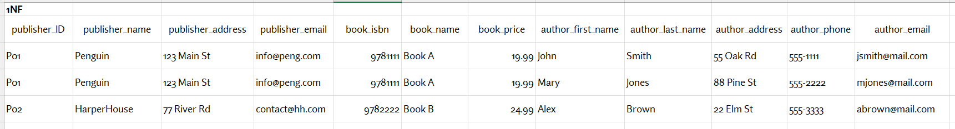
3NF
